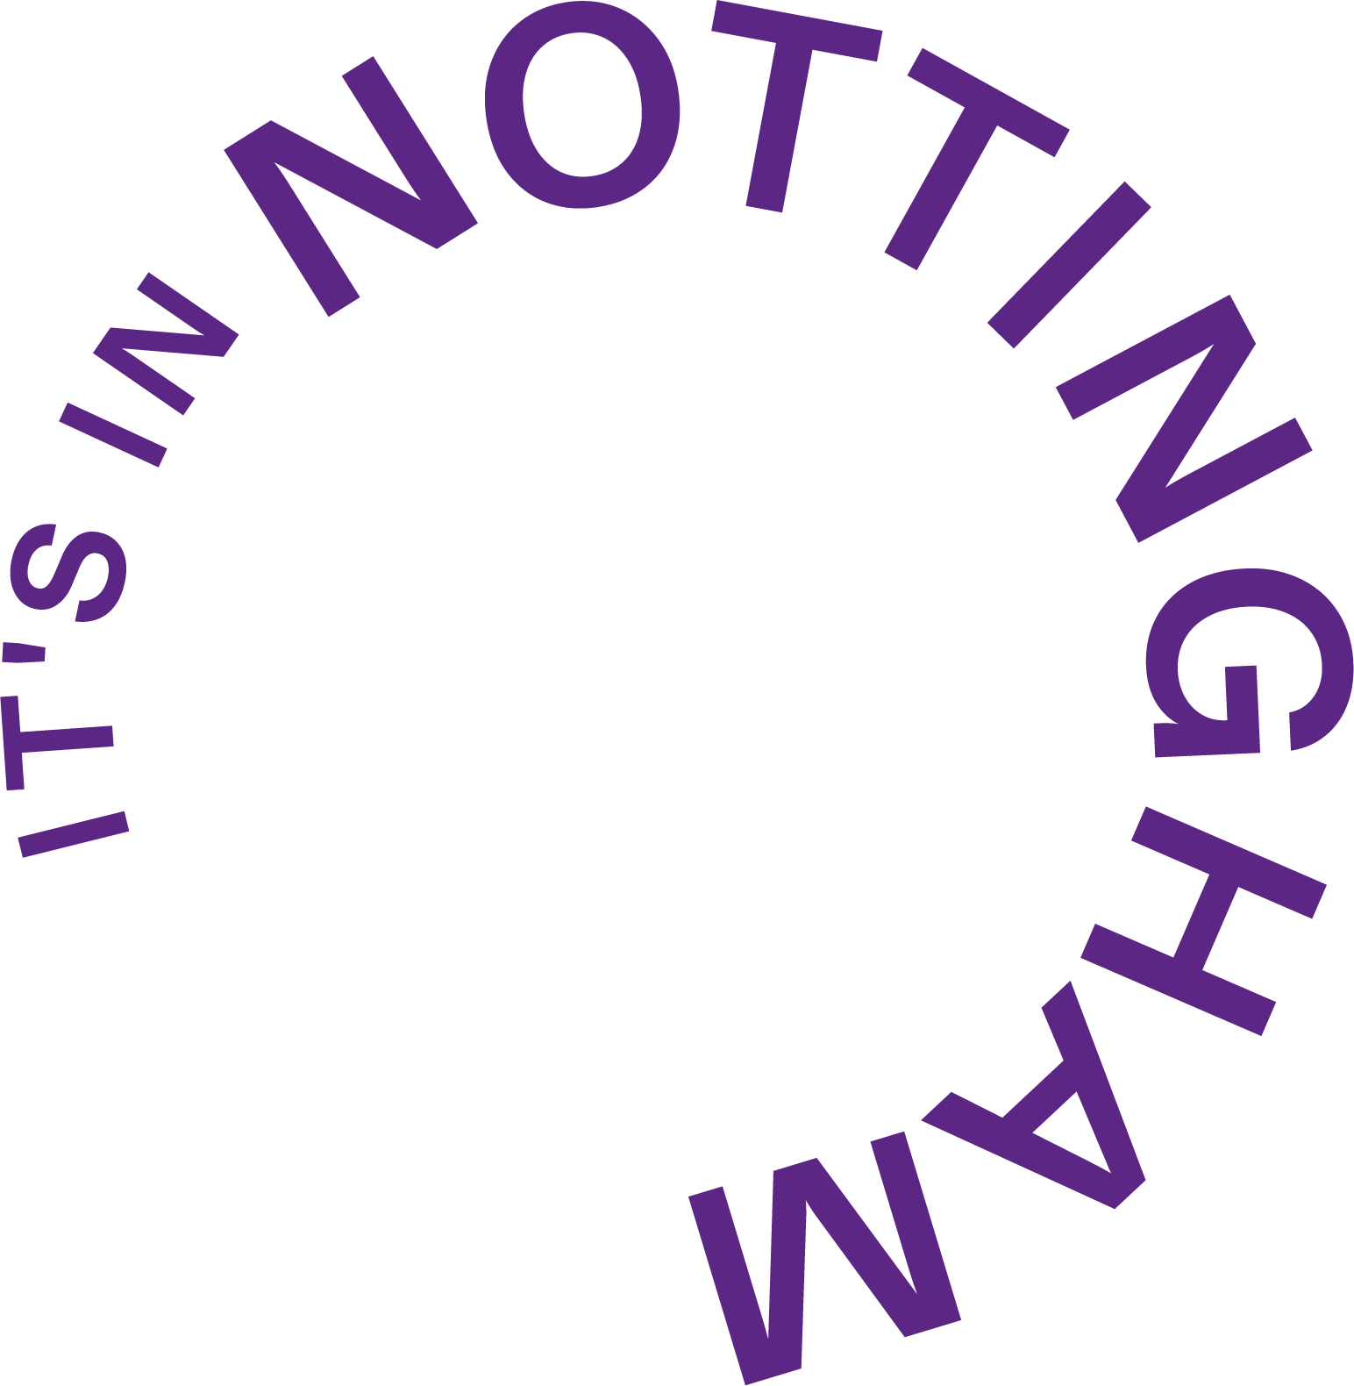

**15 July 2024**

### **Robin Hood Adventure Trail: Free Summer Fun for Families!**

**Join It’s in Nottingham for an exciting family adventure across the city**

This summer, It’s in Nottingham invites families to embark on an exciting adventure with the Robin Hood Adventure Trail. This free event encourages families to help the legendary Robin Hood find his merry friends hidden across various cultural venues in Nottingham city centre.

Families can pick up a trail map from any of the participating venues and explore the city to uncover the hidden characters. The adventure begins from any location, but don’t miss out on finding every character! Once all the characters are found and noted, participants can head to the National Justice Museum on High Pavement to claim their special Robin Hood badge as a memento of their adventure.

As a bonus, the first 200 people to pick up a map from Nottingham Contemporary, will receive a free Robin Hood hat!

Participating venues include:

* Broadway Cinema
* Motorpoint Arena
* National Justice Museum
* Nottingham Arts Theatre
* Nottingham Castle
* Nottingham Contemporary
* Theatre Royal & Royal Concert Hall
* The City of Caves

Alternatively, the trail map can be downloaded [here.](https://cdn.sanity.io/files/qjsm7swb/production/d6bf3f7ade29f21e91e578fb74fcef833dfdaa26.pdf)

*"This is a fantastic opportunity for families to explore the cultural venues that Nottingham has in the city and engage with its rich heritage in a fun and interactive way,"* ***said Alex Flint, CEO of It’s in Nottingham****. "We are excited to see families enjoy the Robin Hood Adventure Trail and create lasting memories."*

Commenting on the trail,***Lauren Williams, Hospitality and Events Sales Manager said:*** *“We are delighted that both the National Justice Museum and the City of Caves are part of the Robin Hood Adventure trail this summer. Staff at the National Justice Museum are particularly looking forward to seeing all the families who complete the trail and come to collect their special badge.”*

Don’t miss out on this fantastic free summer activity. Gather your family, put on your Robin Hood hat, and explore our amazing city and all it has to offer!

**END**

**Image attached.**

**About It’s in Nottingham:**

* It’s in Nottingham – Nottingham’s business improvement district – is a not-for-profit company that is privately funded by member businesses and organisations in the retail, leisure, hospitality, office and education sectors within a defined area in Nottingham city centre
* With over 700 members, It’s in Nottingham is one of the largest Business Improvement Districts in the country
* It’s in Nottingham aim is to put Nottingham firmly on the map as a regional and national city to live, study, work and play, by delivering a range of initiatives which are driven and shaped by the members for their benefit
* It’s in Nottingham is the brand used by Nottingham BID Company Ltd. to promote the city which includes delivering campaigns and events throughout the year as well as a dedicated website and social media accounts

For further information please contact: [judi@itsinnottingham.com](mailto:judi@itsinnottingham.com) | 07811 323373