Eva Koťátková: How many giraffes are in the air we breathe?
27 May – 3 Sep 2023

Eva Koťátková’s installations invite us to enter a different kind of world – one where social rules and relationships are critically reimagined. Combining sculpture, drawing, collage, costumes, text and sound, her vast and playful scenographies centre the agency of the imagination.

Storytelling sits at the heart of the exhibition How many giraffes are in the air we breathe?, which explores the tale of a young giraffe called Lenka. Captured in 1954, Lenka was the first ever giraffe at the Prague Zoo, but survived only two years in captivity. Her body was then donated to the Natural History Museum, only to be exploited as another visitor attraction.

Lenka’s life as a museum object was complicated by blunders in the preservation process, which caused the release of toxic gases and the temporary closure of Prague’s main public square. This exhibition explores this story and all its symbolic possibilities: as an image for the colonization of our bodies and of the non-human world, as well as for the violence of the modern human condition.

The exhibition consists entirely of a new body of commissioned work, including an audio play produced in collaboration with local children from Seely Primary School. This sound work, presented across both of our galleries, voices a collection of narratives and responses related to Lenka’s dual lives as a living animal and as a museum object.

Developed in collaboration with Nottingham Contemporary’s Learning and Exhibitions teams, the exhibition invites visitors to enter into the story of the giraffe and participate in Koťátková’s exploratory world. Create your own version of the story in the giraffe puppet theatre; sit, listen and daydream under a giant suspended net sculpture; and contribute your own stories to our collective story board.

Eva Koťátková: How many giraffes are in the air we breathe? is generously supported by Czech Centre London, and the Eva Koťátková Exhibition Circle: Belinda de Gaudemar, Hunt Kastner & those who wish to remain anonymous.

RELATED EVENTS

Exhibition Walkthroughs
Wednesday 31 May, 12pm
Welcome walkthrough
Explore the exhibition with our team and partners, and join us for refreshments and conversation in the café afterwards.
Wednesday 12 July, 2pm
Curator’s Walkthrough
Learn more about the exhibitions with Nicole Yip, Chief Curator and Niall Farrelly, Assistant Curator.

12.30pm every Tuesday, Thursday and Saturday, starting Tuesday 6 June
Join one of our friendly Gallery Assistants for a short exploration of one of our exhibitions. For more details visit our website.

Emergency & Emergence
All the Birds Sing Bass
19–25 June

How can we form alliances that strengthen our communication strategies and ability to listen? Can we create new maps of what is (un)heard to remember collective experiences, recognise non-human actions, and conspire new myths? Join us for performance, conversation, music, a workshop and screening, taking place over the week of 19–25 June.
Free Family Activities
Spring Half-Term
30 May – 1 June, 10am – 12pm & 1pm – 3pm

Summer Holidays
1 – 24 Aug, 10am – 12pm & 1pm – 3pm (Tue, Wed & Thurs)
Explore the themes in the exhibitions through making and play. For more details visit our website.
For more information about the exhibition, related events and learning programmes, visit nottinghamcontemporary.org or scan here:

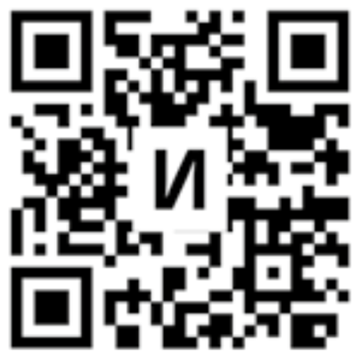

Nottingham Contemporary is a registered charity and dependent on the generosity of our visitors, partners and supporters. Donate today to directly support our ambitious exhibitions, and the vital work we do with artists, schools, young people, and our local community.
Suggested donation: £3

If you would like a calm space to reflect after your visit, please feel free to use Gallery 0 (room adjacent to Gallery 1), where you can also find support resources and tools. Please speak to a member of staff for more information.

