Eva Kot’átková : How Many Giraffes are in the Air we Breathe?
27 May – 3 September 2023

RELATED EVENTS
Exhibition Walkthroughs
Wednesday 31 May, 12pm
Welcome walkthrough
Explore the exhibition with our team and partners, and join us for refreshments and conversation in the café afterwards.
Wednesday 12 July, 2pm
Curator’s Walkthrough
Learn more about the exhibitions with Nicole Yip, Chief Curator and Niall Farrelly, Assistant Curator.
12.30pm every Tuesday, Thursday and Saturday, starting Tuesday 6 June
Join one of our friendly Gallery Assistants
for a short exploration of one of our current exhibitions. For more details visit our website.
Emergency & Emergence
All the Birds Sing Bass
19–25 June
How can we form alliances that strengthen our communication strategies and ability to listen? Can we create new maps of what is (un)heard to remember collective experiences, recognise non-human actions, and conspire new myths? Join us for performance, conversation, music, a workshop and screening, taking place over the week of 19–25 June. For more details visit our website.
Free Family Activities
Spring Half-Term
30 May–1 June, 10am–12pm & 1pm–3pm
Summer Holidays
1–24 Aug, 10am–12pm & 1pm–3pm
(Tue, Wed & Thurs)
Explore the themes in the exhibitions through making and play. For more details visit our website.

Eva Kot’átková: How many giraffes are in the air we breathe? is generously supported by Czech Centre London, and the Eva Kot’átková Exhibition Circle: Belinda de Gaudemar, Hunt Kastner & those who wish to remain anonymous.
Exhibition graphics by Åbäke.
For more information about the exhibition, related events and learning programmes, visit nottinghamcontemporary.org or scan here:
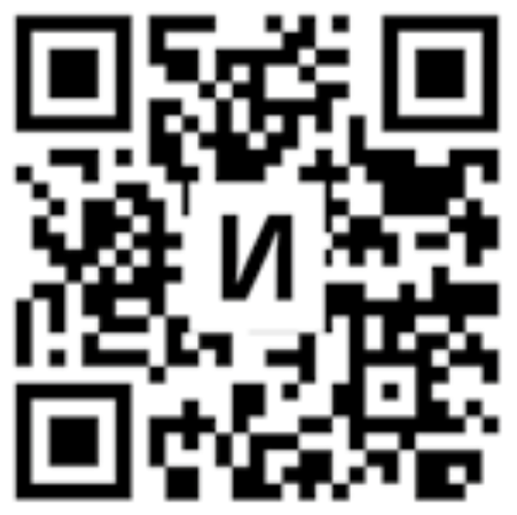
Nottingham Contemporary is a registered charity and dependent on the generosity of our visitors, partners and supporters. Donate today to directly support our ambitious exhibitions, and the vital work we do with artists, schools, young people, and our local community.
Suggested donation: £3
If you would like a quiet space to reflect during your visit, please visit Gallery 0 (room adjacent to Gallery 1).
Environmental: Nottingham Contemporary is committed to advancing sustainability within the organisation and aims to explore and embed sustainable working practices and habits within our workplace and across the sector. This includes standardising environmental considerations at all stages of decision making.
Many of the materials in How many giraffes are in the air we breathe? have been repurposed, and the exhibition build will be reused for our Autumn season. This document is printed on FSC Mix paper (Forest Stewardship Council ® certified products manufactured with a variety of sources including FSC-certified virgin fibre, controlled wood and/or recycled materials). Please return to a member of staff or recycle should you not want to keep after your visit.

