This access statement does not contain personal opinions as to our suitability for those with access needs, but aims to accurately describe the facilities and services that we offer all our guests/visitors.
Access Statement for Nottingham Contemporary

Introduction
Nottingham Contemporary is easy to find, and easy to get to. You can’t miss our green and gold building – it’s in the city centre, in the heart of the Lace Market. We are one of the UK's leading contemporary art galleries. We present changing exhibitions of international contemporary art, public programmes that include films, talks, symposiums and study sessions. We also offer family activities, live music and regular gallery talks.
The building is made up of three levels. The first floor is situated on street level where our galleries, main reception and shop are located. There is lift access to the other two floors where you will find lockers, The Space (our performance auditorium), The Studio (our workshop space), our café (Ottar at Contemporary) and toilet facilities including a changing places toilet.
You will find members of our front of house team on Reception and in the Galleries should you require any assistance.
We look forward to welcoming you. If you have any queries or require any assistance please phone 0115 948 9750 or email info@nottinghamcontemporary.org.

Pre-Arrival
- For full details and maps of how to reach us please see the Visit section of our website. Alternatively, you can plan your journey by car or public transport using a journey planning website; simply enter your postcode and ours, which is NG1 2GB to get directions.
- The nearest railway station is Nottingham, which is 0.4 miles away (a 8-12 minute walk). We are one tram stop from the station; Lace Market stop. Taxis are available at the station. If you require an accessible taxi you can book this in advance.
- The nearest tram stop is Lace Market which is 0.1 miles away (a 3 minute walk) down a slightly sloped road. The nearest bus stop is 0.1 miles away for local buses. For more public transport details please see our Visit Us webpage.
- The main road outside the gallery is a wide paved path.
- A large print copy of our exhibition programme and exhibition notes are available to view at reception. Large print exhibition labels and wall captions are available to view in the galleries - just one of ask a gallery assistants.

Car Parking and Arrival
- There is a drop off point 10 metres from the from entrance but with no dropped curb. A seating bench is available just inside the entrance. There are no handrails at this point.
- There is no on site parking. There is limited on street parking for Blue Badge holders for a maximum of 3 hours on High Pavement. Please display your badge and clock clearly.
- The nearest car park is Lace Market. A 2 minute walk away on flat terrain. The car park postcode is NG1 1QE.
- Stoney Street car park is also a short walking distance please visit their websites for details.
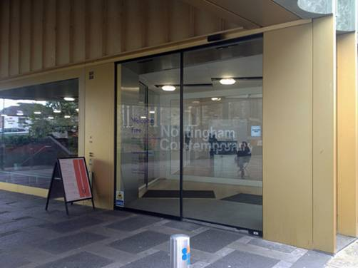
- The main entrance door to Nottingham Contemporary is automatic and is 1210mm/47.5inches wide.
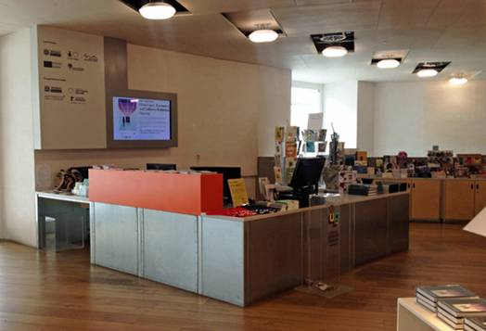

Main Entrance, Reception and Ticketing Area
- The main entrance, reception, galleries and shop is situated on street level with step free, level access throughout.
- There are cushioned benches to sit on in this area.
- The floor surface is wooden.
- The area is evenly and well lit with overhead lighting from fluorescent and spot lights.
- There is a lowered section of the reception desk and shop till.
- There is a hearing loop installed at reception.
- A magnifying glass, pen and pad of paper are available at reception.
- Wheelchair loan and portable seats are available to use free of charge, on request.
- Entry to the gallery exhibitions is free for all.
- Some music and performance events are ticketed.

Attraction
- The exhibitions are presented off the main entrance on Level 3 within four galleries which are all accessible from the main shop/reception area. There is also a study off gallery 1.
- Levels 1 and 2 are accessible by stairs or the passenger lift.
- Lift measurement: Door width 900mm/35 inches, floor depth 1400mm/55inches, floor width 1340mm/52inches.
- To access the galleries there are semi-automatic doors 1130mm/44 inches in width
- Titles and descriptions of the work are on wall text 1030mm/40 inches from ground level. Exhibition notes are provided for further explanations.
- There are returnable, laminated large print versions of all of these available so please ask a member of the team.
- Gallery Assistants are available in each gallery to answer questions you may have. Weekday spot talks are available free of charge, please see our main website for details of times.
- The exhibitions change 3 times a year. Lighting, sound and positioning of objects will change with each exhibition in the galleries. A full risk assessment is carried out before each exhibition and any required caution signage is present outside the galleries. Please contact us if you have questions regarding this.
- Written transcripts and or subtitles are usually available for videos produced by Nottingham Contemporary which are used provide information about our services. However, please note that subtitles and transcripts for artist produced video artworks, sound pieces and films exhibited in our galleries are not always available.
- The floor surfaces are wooden or concrete throughout the building.

Public Toilets
- Public toilets are located on Level 1. Accessible using the lift or stairs. They are situated outside The Space and in the our café areas.
- We have two accessible WC's in this location with right hand transfer to WC.
- A Changing Places WC is also available, however no shower is provided for the changing places table. From Monday 4 December access to the Changing Places toilet at Nottingham Contemporary art gallery will require a RADAR key. Keys will be provided on request at Reception and in the Cafe for visitors who don't carry their own. You can get further information about the RADAR key scheme from the RADAR website. You should be able to obtain a RADAR key by contacting the Access Officer at your local authority. For those who can't get a RADAR key from your local authority, you can obtain one from RADAR directly for a small charge.

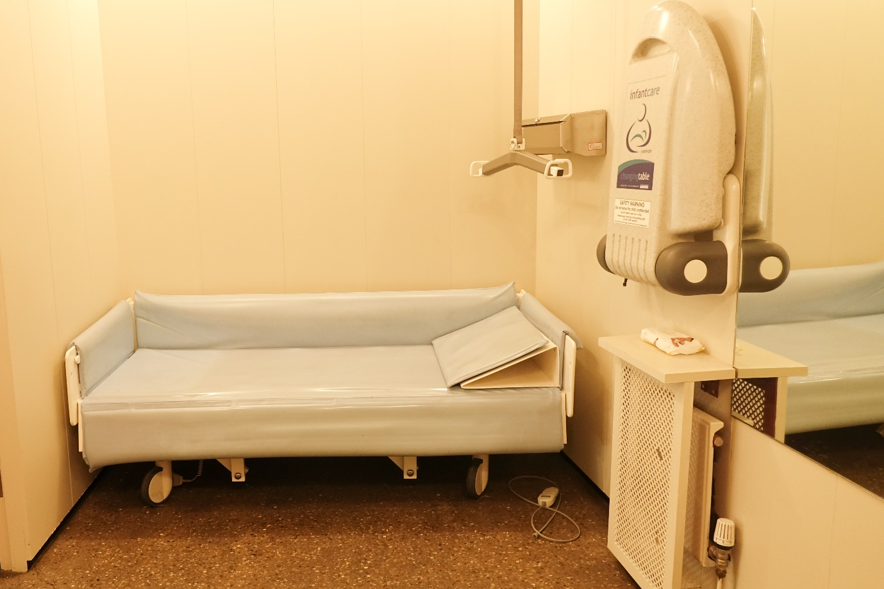
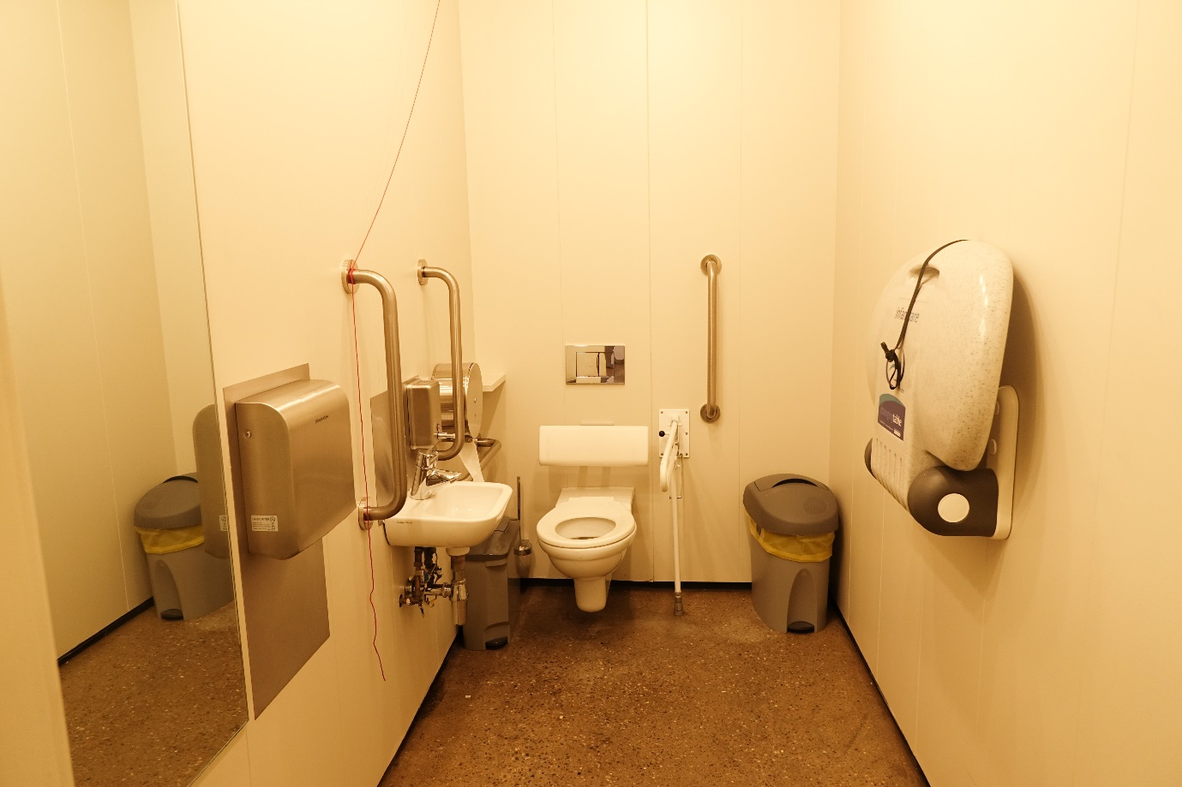
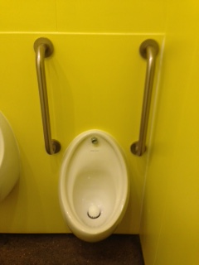
- There are also ambulant cubicles and a lowered urinal with vertical hand rails.
- The taps on the sinks are automatic.
- The floor surface is non slip concrete.
- Well lit automatic lighting.
- There is an emergency alarm cord.
- A light flashes when the fire alarm sounds.
- Accessible WC measurements: Door width: 870mm/34 inches. Toilet height is 470mm/18.5 inches. Sink height: 720mm/28inches.
- Changing Places measurements: Door width: 870mm/34 inches. Toilet height is 460mm/18.9 inches. Sink height 740mm/29 inches.

Catering
- Our cafe is situated on Level 1 accessible via the stairs or lift.
- There is step free access throughout this area which includes an accessible WC and outside patio.
- The entrance is 1510mm/59 inches wide.
- We offer table service and our staff are always happy to go through the menu with you.
- Lighting is natural daylight and florescent over head lights.
- There is a mixture of sofas and arm chairs with low tables as well as dining tables and upright chairs. Tables height are 745mm/29.4 inches. Upright chairs with no arms height from the floor is 465mm/18.5 inches. Sometimes our café furniture is moved around to accommodate a small stage for performers.
- We do our best to cater for any dietary requirements. Please let us know on arrival of specific requests you may have.
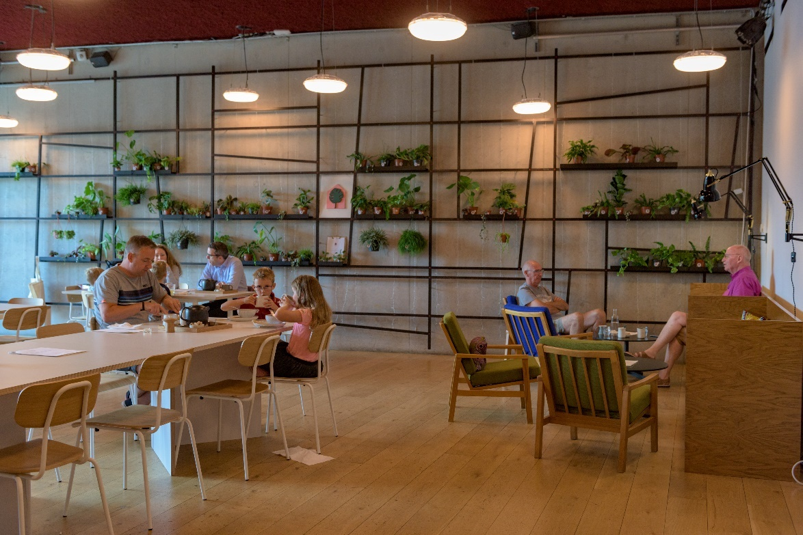
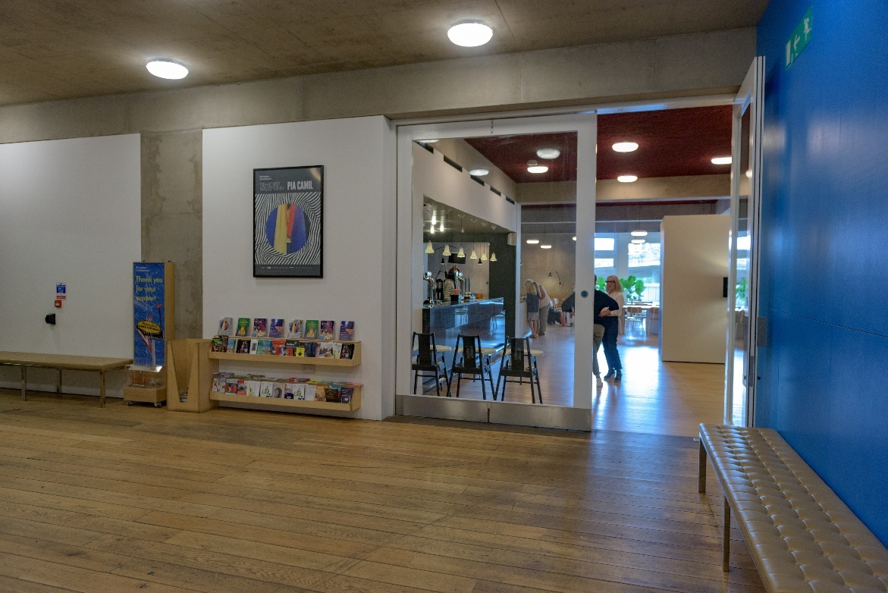
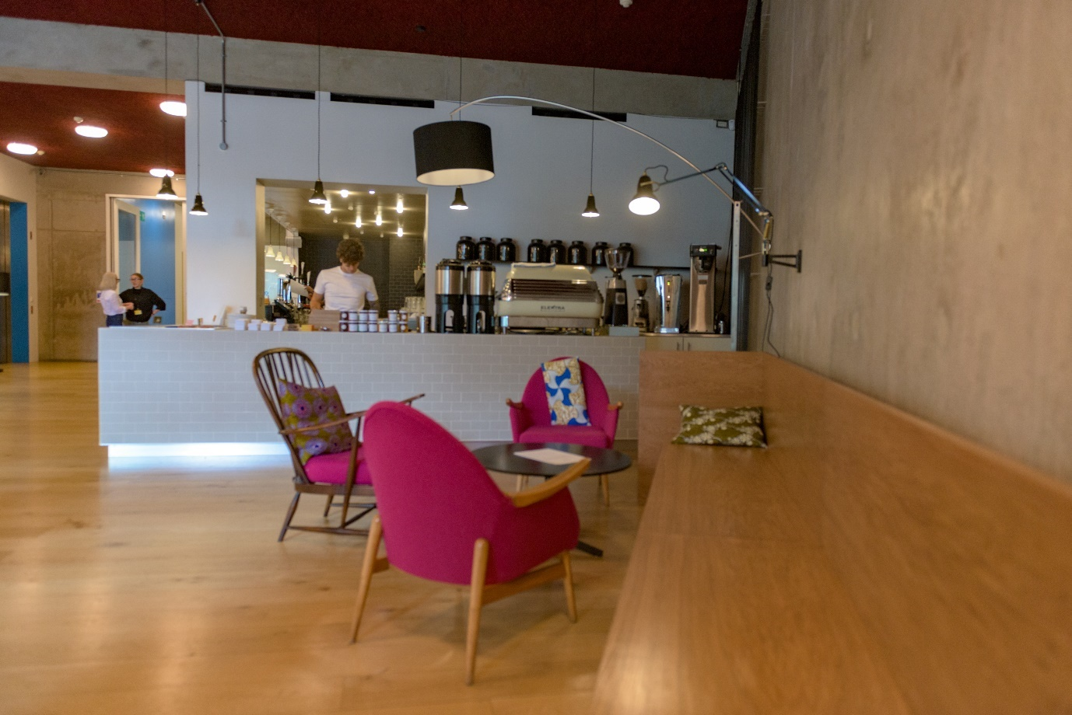

Shop
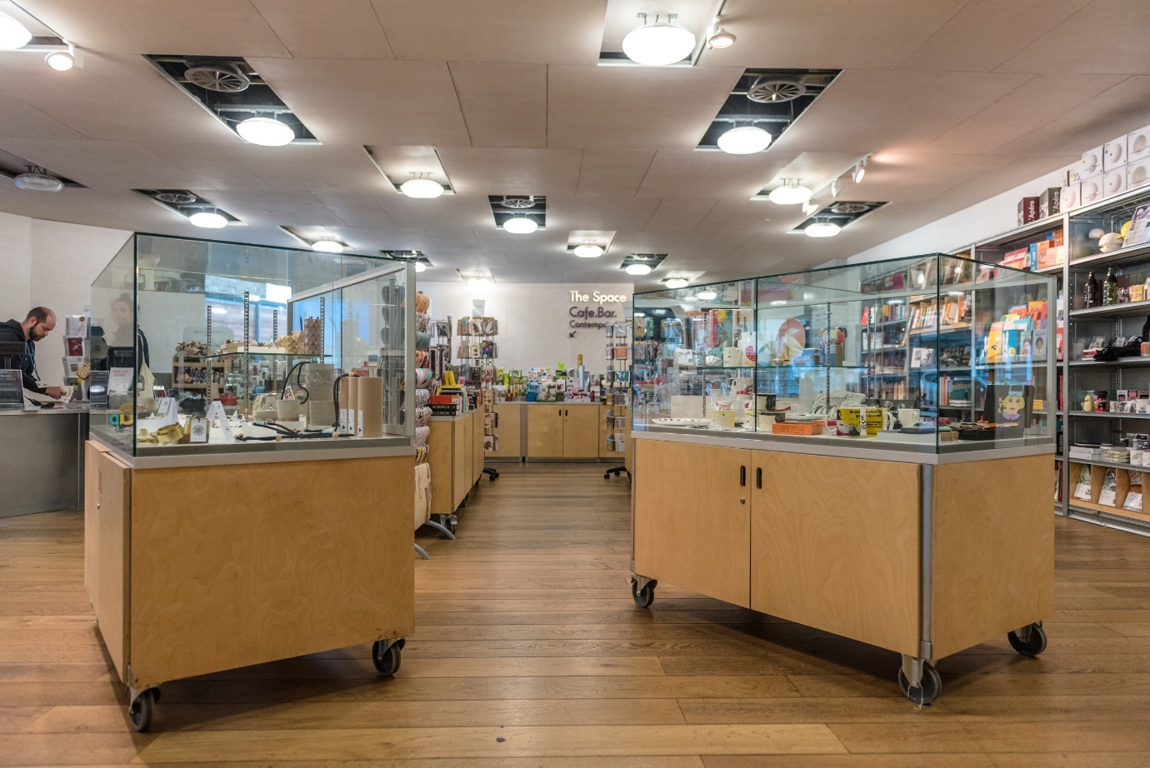

- Our shop is located just within the main entrance. It includes jewellery, home-ware, books, gifts, catalogues and limited edition artist prints.
- The shop is level throughout.
- A low level desk and counter is provided for purchases.
- There are some tall display racks and some lower tables accessible from a seated position.
- Staff will offer assistance if required.
- Hearing loop system available and signage.
- There is a bench provided for sitting in this area.
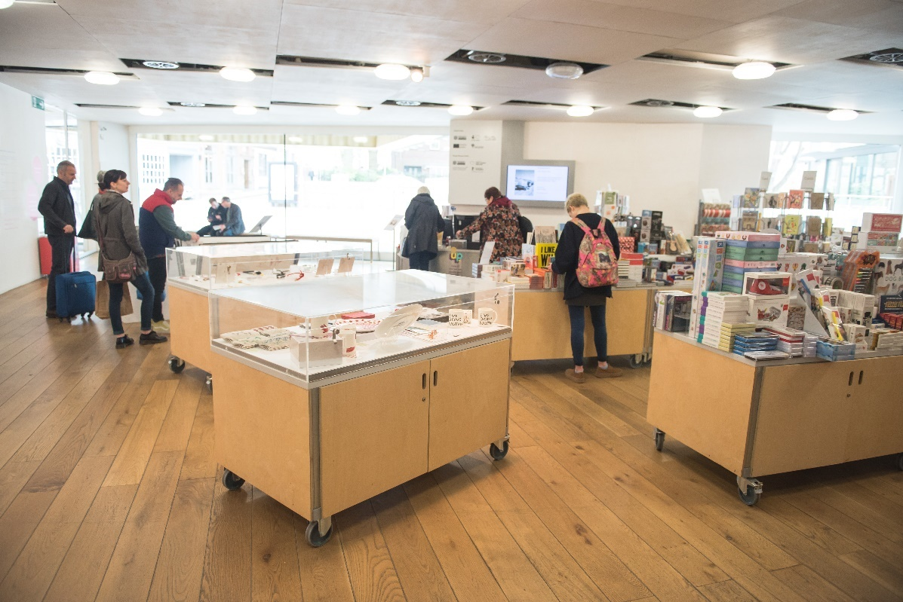
Additional Information
- All our staff receive training that includes disability awareness training.
- We have a set of evacuation procedures in the event of an emergency. Staff will direct you to the nearest emergency exit, which will lead to the outside of the building. Some emergency exit routes include stairs. If you are unable to use the stairs, you will wait in a safe refuge with intercom communication to reception until the emergency services arrive and assist you to leave the building.
- We welcome trained assistance dogs. A water bowl is available at Reception.
- Large print versions of our information are available to view.
- For further information on accessible destinations in the area please visit https://www.visit-nottinghamshire.co.uk or speak to a member of staff.

Contact Information
Address (Inc postcode): | Nottingham Contemporary Weekday Cross Nottingham NG1 2GB
Telephone: | 0115 948 9750
Minicom: | n/a
Email: | info@nottinghamcontemporary.org
Website: | www.nottinghamcontemporary.org
Grid Reference: | n/a
Hours Of Operation: | Tuesday-Saturday 10-pm, Sunday 11-5pm
Local Carers: | n/a
Local Equipment Hire: | n/a
Local Accessible Taxi: | D&G Taxi www.dgcars.co.uk 0115 9500 500
Local Public Transport: | Tram: www.thetram.net 0115 942 7777 Bus: www.nctx.co.uk travelcentre@nctx.co.uk 0115 950 6070 Train: nationalrail.co.uk Nottingham Train Station, Carrington Street. 0121 634 2040

