This access statement does not contain personal opinions as to our suitability for those with access needs, but aims to accurately describe the facilities and services that we offer all our guests/visitors.

**Access Statement for Nottingham Contemporary**

**Introduction**

Nottingham Contemporary is in Nottingham city centre, in the heart of the Lace Market. We are one of the UK's leading contemporary art galleries. We present changing exhibitions of international contemporary art, events that include films, talks and performances. We also offer family activities and regular gallery tours.   
  
The building is made up of three levels. The first floor is situated on street level where our galleries, main reception and shop are located. There is lift and stairs access to the other two floors where you will find lockers, The Space (our performance auditorium), The Studio (our workshop space), our café (Blend at Contemporary) and toilet facilities including a changing places toilet.  
  
You will find members of our front of house team at our reception desk and in the Galleries should you require any assistance.

We look forward to welcoming you. If you have any queries or require any assistance, please phone 0115 948 9750 or email info@nottinghamcontemporary.org.

**Pre-Arrival**

* For full details and maps of how to reach us please see the [Visit section](https://www.nottinghamcontemporary.org/visit/getting-here/) of our website. Alternatively, you can plan your journey by car or public transport using a journey planning website – search for Nottingham Contemporary or use our postcode which is NG1 2GB to get directions.
* The nearest railway station is Nottingham, which is 0.4 miles away (a roughly 8 minute walk). Taxis are available at the station. If you require an accessible taxi you can book this in advance. We suggest local firm D&G Taxi www.dgcars.co.uk 0115 9500 500
* We’re accessible by tram using the Lace Market Tram stop which is 0.1 miles / 3 minute walk from our building. The Lace Market Tram Stop is only one stop (0.3 miles) from Nottingham Railway Station and one stop (0.3 miles) from Old Market Square.
* Our nearest bus stop is Fletcher Gate H1 which is served by NCT (Nottingham City Transport) green, navy and turquoise lines. We are also a 5-10 minute walk from Victoria Centre (shopping centre) bus stops which are served by most city bus routes.
* The main road outside the gallery is a wide paved path.

**Car Parking and Arrival**

* There is a drop off point 10 metres from the from entrance but with no dropped curb. A seating bench is available just inside the entrance. There are no handrails at this point.
* There is no on site parking. There is limited on street parking for Blue Badge holders for a maximum of 3 hours on High Pavement. Please display your badge and clock clearly.
* The nearest City Council public car parks are [Lace Market](https://nottinghamcity.gov.uk/information-for-residents/transport-parking-and-streets/parking-and-permits/city-centre-parking/car-parks/lace-market) (sat nav NG1 1QE) and [Broadmarsh](https://parking.nottinghamcity.gov.uk) (sat nav NG1 7FE).
* 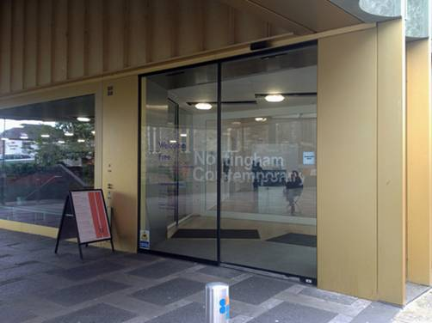The main entrance door to Nottingham Contemporary is automatic and is 1210mm/47.5inches wide.

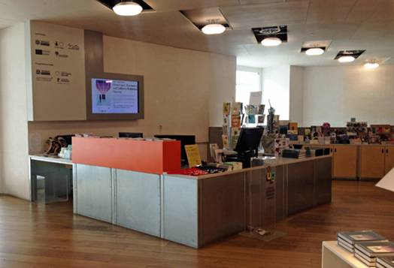

**Main Entrance, Reception and Ticketing Area**

* The main entrance, reception, galleries and shop is situated on street level with step free, level access throughout.
* There are cushioned benches to sit on in this area.
* The floor surface is wooden.
* The area is evenly and well lit with overhead lighting from fluorescent and spot lights.
* There is a lowered section of the reception desk and shop till.
* There is a hearing loop installed at reception.
* A magnifying glass, pen and pad of paper are available at reception.
* Wheelchair loan and portable seats are available to use free of charge, on request.
* Entry to the gallery exhibitions is free for all. As a charity, we rely on and encourage donations. If you are able to donate, you can do so [online](https://www.nottinghamcontemporary.org/support/) or at cash and contactless donation points throughout the building. Our recommended donation is £5 per person.
* Some music and performance events are ticketed. Tickets are bookable at our reception desk or at [nottinghamcontemporary.org](http://nottinghamcontemporary.org/)

**Attraction**

* The exhibitions are presented off the main entrance on Level 3 within four galleries which are all accessible from the main shop/reception area. There is also a space called Gallery 0 which contains books, stim toys and exhibition resources, located off Gallery 1.
* Levels 1 and 2 are accessible by stairs or the passenger lift.
* Lift measurement: Door width 900mm/35 inches, floor depth 1400mm/55inches, floor width 1340mm/52inches.
* To access the galleries there are semi-automatic doors 1130mm/44 inches in width.
* Overviews of the exhibition are on wall text 1030mm/40 inches from ground level. Some exhibitions also have additional captions for individual artworks on the walls displayed at the same height. A3 Exhibition notes are provided for further explanations. You can take these home with you if you’d like to.
* There are returnable large print versions of all of these available at our reception desk and in our galleries. Audio recordings of all of these texts are also available on the [record section](https://www.nottinghamcontemporary.org/record/) of our website.
* There are returnable easy read guides to our exhibitions at our reception desk and in our galleries. These are also available on the [record section](https://www.nottinghamcontemporary.org/record/) of our website.
* We offer audio descriptions of some of the artworks in our galleries. These are available on mp3 players which you can borrow from our reception desk or you can listen on your own device by visiting the [record section](https://www.nottinghamcontemporary.org/record/) of our website.
* Gallery Assistants are available in each gallery to answer questions you may have. We offer regular gallery tours with guest speakers and 12.30 Talks at 12.30pm every Tuesday, Thursday and Saturday with members of our team free of charge, please see the [what’s on](https://www.nottinghamcontemporary.org/whats-on/) page of our website for details.
* The exhibitions change 3 times a year. Lighting, sound and positioning of objects will change with each exhibition in the galleries. A full risk assessment is carried out before each exhibition and any required caution signage is present outside the galleries. Please contact us if you have questions regarding this.
* Written transcripts and or subtitles are usually available for videos produced by Nottingham Contemporary which are used to provide information about our services. However, please note that subtitles and transcripts for artist produced video artworks, sound pieces and films exhibited in our galleries are not always available.
* The floor surfaces are wooden or concrete throughout the building.

**Public Toilets**

* Public toilets are located on Level 1 accessible using the lift or stairs. There are male and female toilets and an accessible toilet with right hand transfer to WC situated outside The Space. There are gender neutral toilets and a Changing Places WC in our café area.
* There is no shower is provided for the changing places table. Access to the Changing Places toilet at Nottingham Contemporary art gallery requires a RADAR key. Keys will be provided on request at Reception and in the Café for visitors who don't carry their own. You can get further information about the RADAR key scheme from the [RADAR website.](http://www.disabilityrightsuk.org/radar-keys) You should be able to obtain a RADAR key by contacting the Access Officer at your local authority. For those who can't get a RADAR key from your local authority, you can obtain one from [RADAR directly for a small charge](http://www.disabilityrightsuk.org/radar-keys).

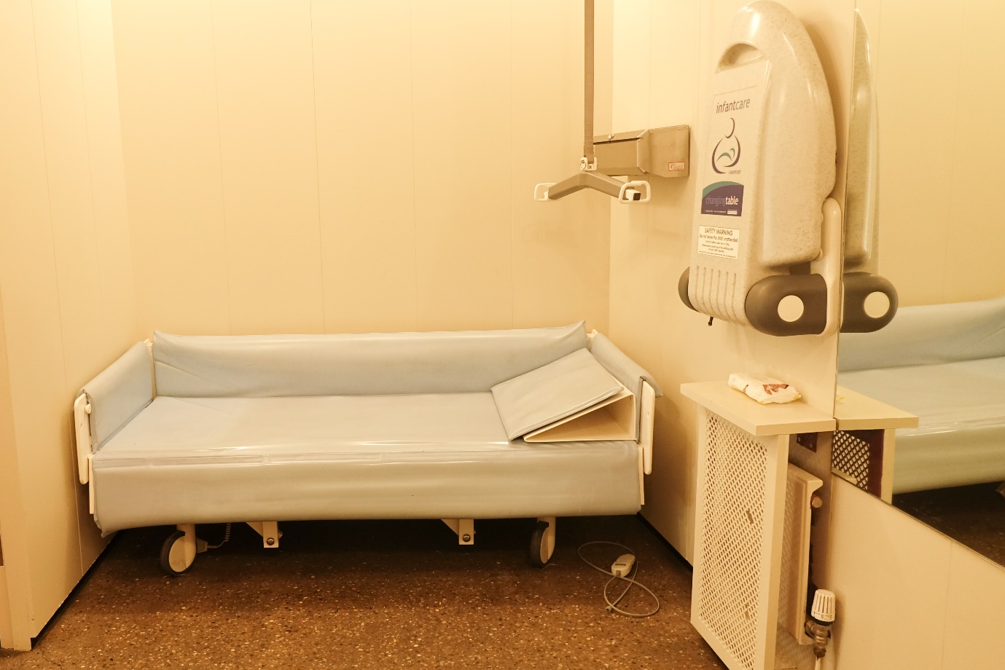

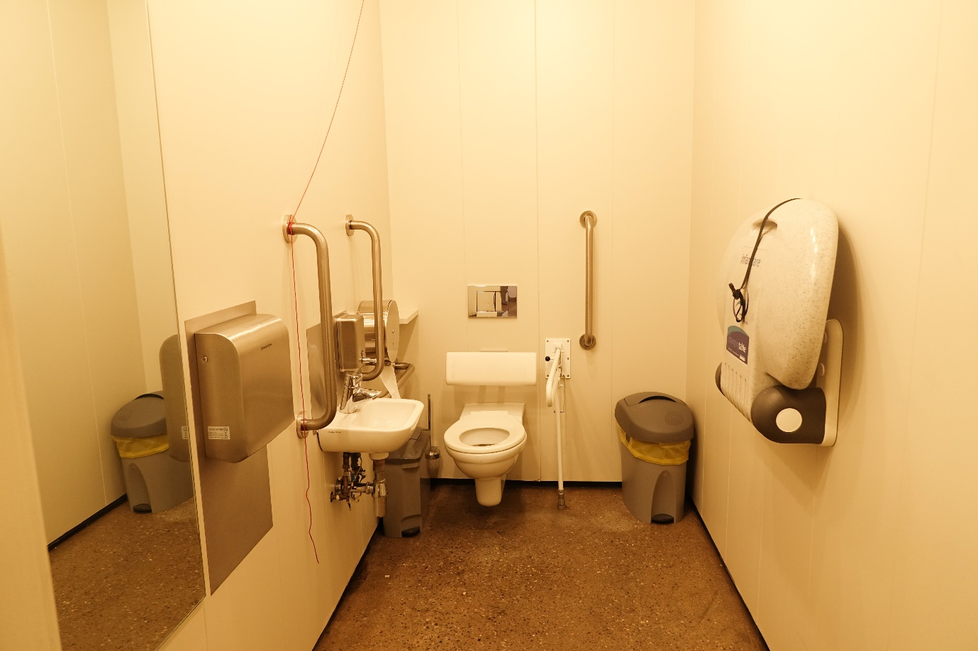

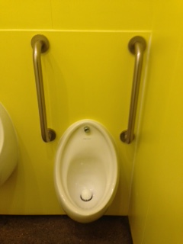

* The floor surface is non slip concrete.
* There is well lit automatic lighting.
* There is an emergency alarm cord in our changing places and accessible WCA.
* A light flashes when the fire alarm sounds.
* Accessible WC measurements: Door width: 870mm/34 inches. Toilet height is 470mm/18.5 inches. Sink height: 720mm/28inches.
* Changing Places measurements: Door width: 870mm/34 inches. Toilet height is 460mm/18.9 inches. Sink height 740mm/29 inches.

**Catering**

* Our café is situated on Level 1 accessible via the stairs or lift. Our café is run by Blend at Contemporary.
* There is step free access throughout this area which includes an accessible WC and outside patio.
* The entrance is 1510mm/59 inches wide.
* Please place your order at the counter and staff will bring your food/drink to your table.
* The café takes payments by card only.
* Lighting is natural daylight and fluorescent over head lights.
* There is a mixture of sofas and arm chairs with low tables as well as dining tables and upright chairs. Tables height are 745mm/29.4 inches. Upright chairs with no arms height from the floor is 465mm/18.5 inches. Sometimes our café furniture is moved around to accommodate a small stage for performers.
* We do our best to cater for any dietary requirements. Please let us know on arrival of specific requests you may have.

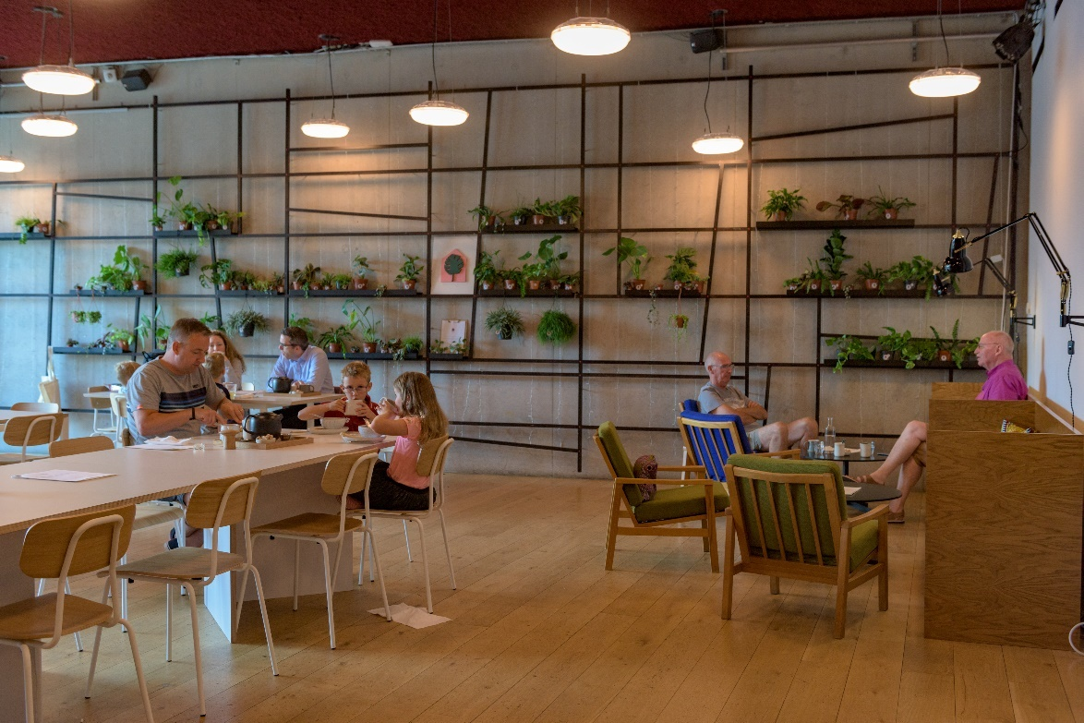

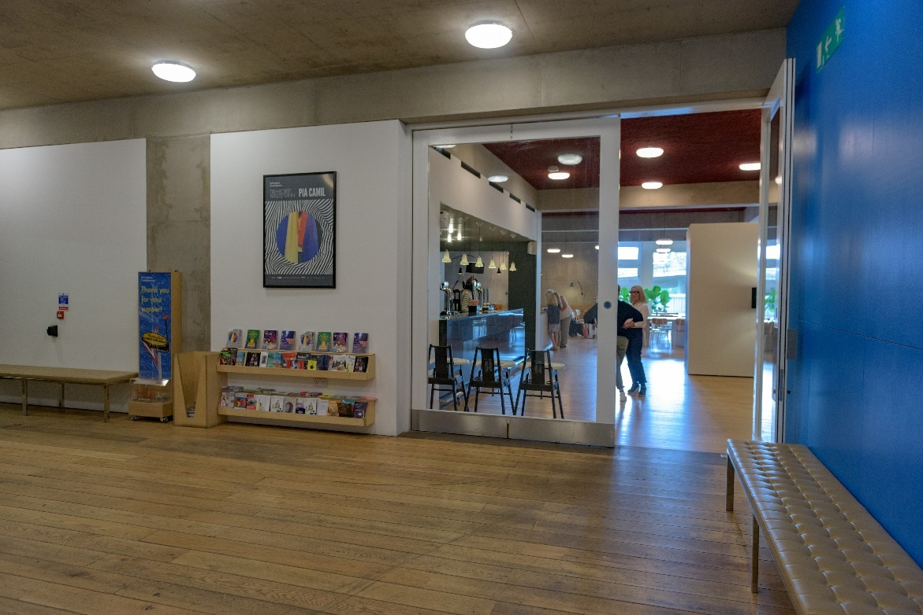

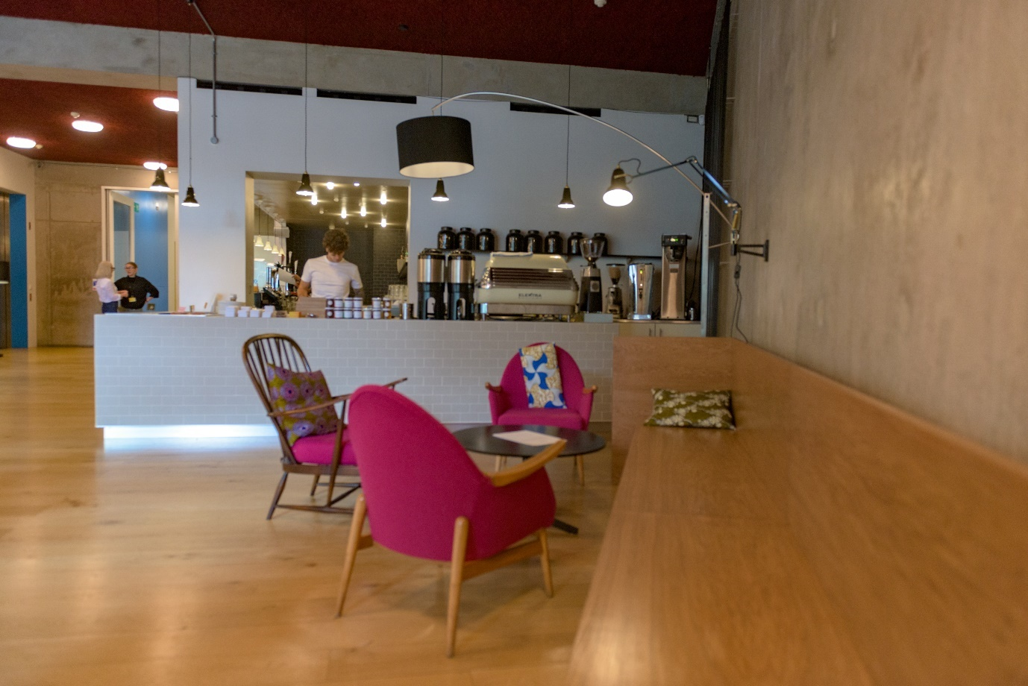

**Shop**

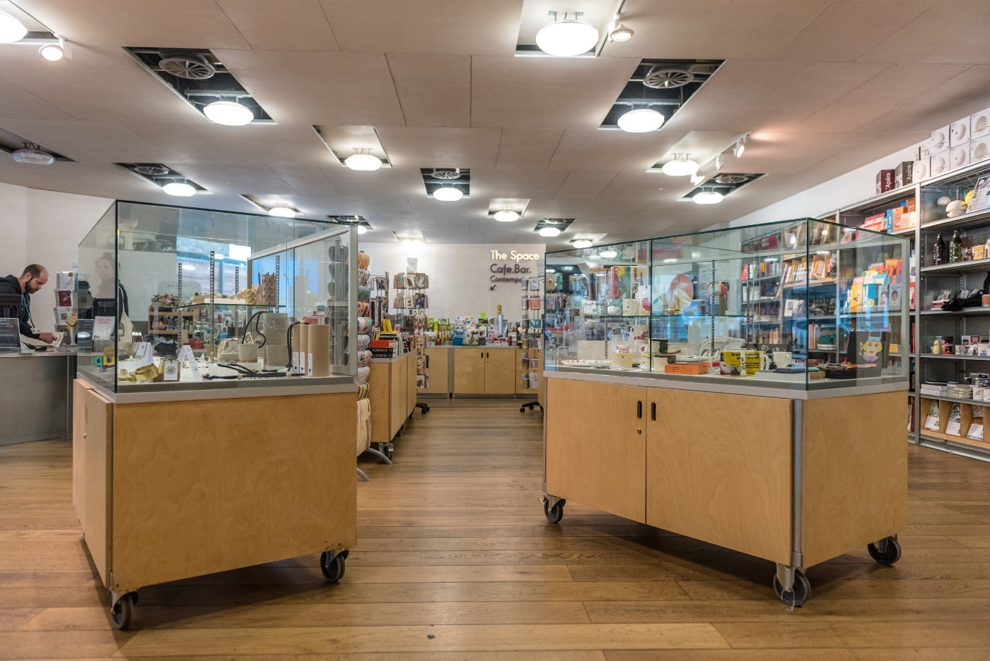

* Our shop is located just within the main entrance. It includes jewellery, home-ware, books, gifts, catalogues and limited edition artist prints.
* The shop is level throughout.
* A low level desk and counter is provided for purchases.
* There are some tall display racks and some lower tables accessible from a seated position.
* Staff will offer assistance if required.
* A hearing loop system is available at the till.
* You can pay by cash or card in our shop.
* There is a bench provided for sitting in this area.

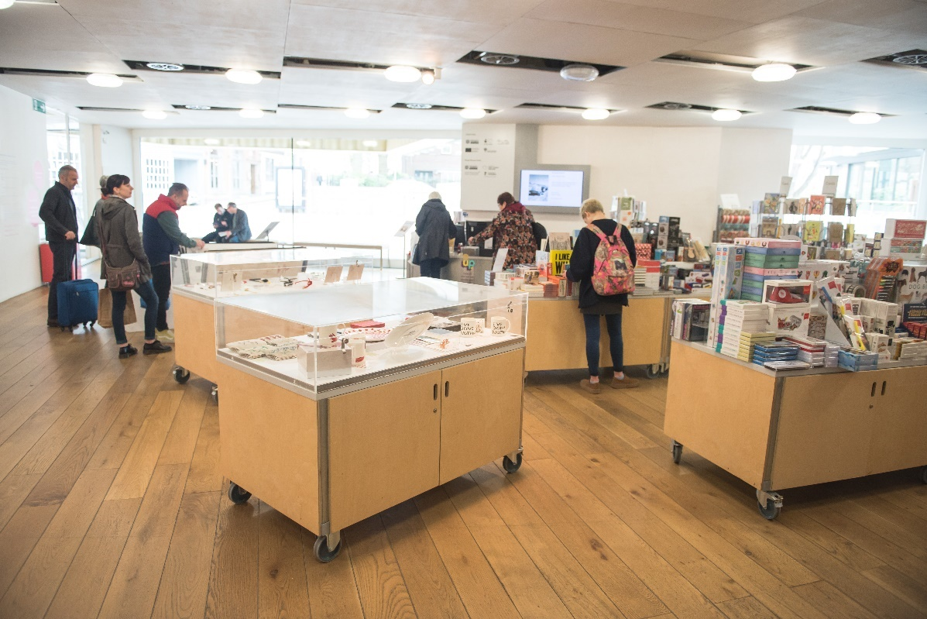

**Additional Information**

* All our staff receive training that includes disability awareness training.
* We have a set of evacuation procedures in the event of an emergency. Staff will direct you to the nearest emergency exit, which will lead to the outside of the building. Some emergency exit routes include stairs. If you are unable to use the stairs, you will be asked to wait in a safe refuge with intercom communication to reception until the emergency services arrive and assist you to leave the building. These refuge areas are the first priority for the fire brigade in the event of a fire.
* For further information on accessible destinations in the area please visit https://www.visit-nottinghamshire.co.uk or speak to a member of staff.

**Contact Information**

|  |  |
| --- | --- |
| Address (Inc postcode): | Nottingham Contemporary Weekday Cross Nottingham NG1 2GB |
| Telephone: | 0115 948 9750 |
| Minicom: | n/a |
| Email: | info@nottinghamcontemporary.org |
| Website: | www.nottinghamcontemporary.org |
| Grid Reference: | n/a |
| Hours Of Operation: | Monday: (shop + café only) 10am-5pm Tuesday-Friday: (galleries, shop + café)10am-5pm Saturday:  (galleries + shop) 10am-6pm  (café) 9.30am-5pm  Sunday: (galleries + shop) 11-5pm (café) 9.30am-5pm |
| Local Carers: | n/a |
| Local Equipment Hire: | n/a |
| Local Accessible Taxi: | D&G Taxi www.dgcars.co.uk 0115 9500 500 |
| Local Public Transport: | Tram: www.thetram.net 0115 942 7777 Bus: www.nctx.co.uk travelcentre@nctx.co.uk 0115 950 6070 Train: nationalrail.co.uk Nottingham Train Station, Carrington Street. 0121 634 2040 |